世界之巔西藏【拉薩・珠峰・阿裡・山南】大環線20天(轉山版)
【青藏鐵路・拉薩・布達拉宮・羊卓雍錯・日喀則・新珠峰大本營・絨布寺・瑪旁雍措・岡仁波齊转山・古格王朝遺址・塔欽・山南】
深度體驗●絕對秘境 專屬定制●獨家線路 風景震撼●保證出片

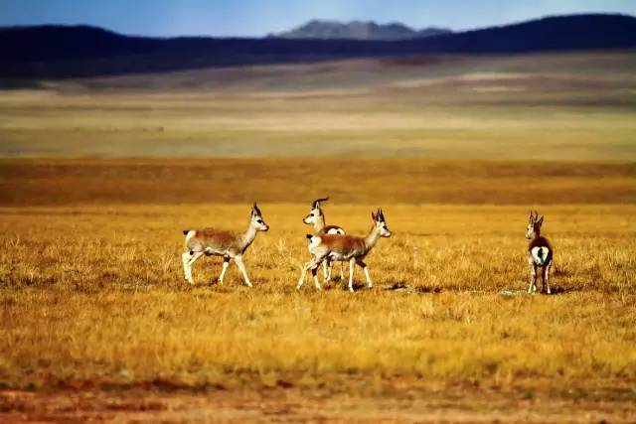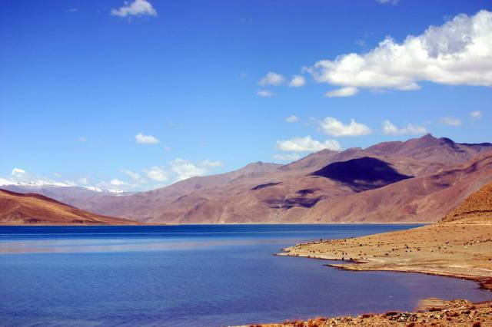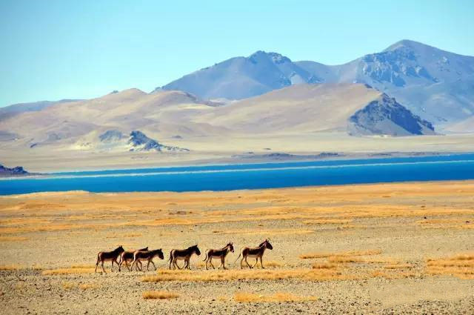
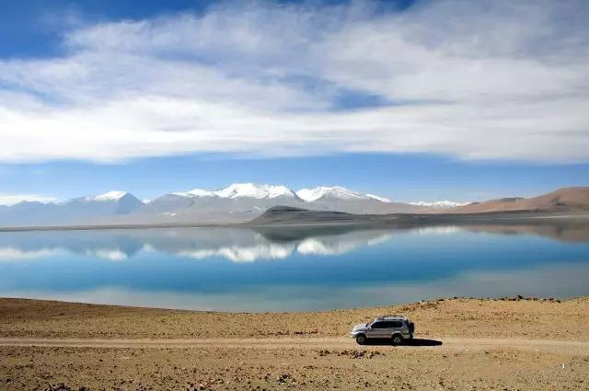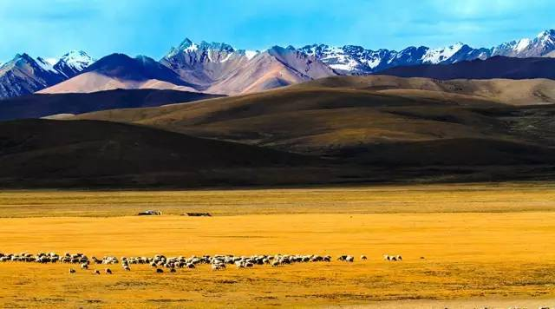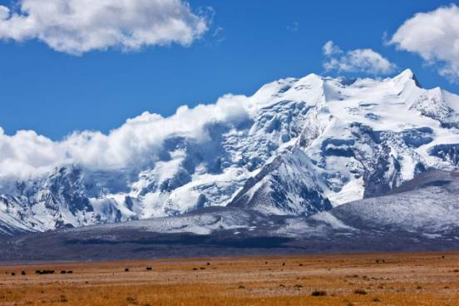
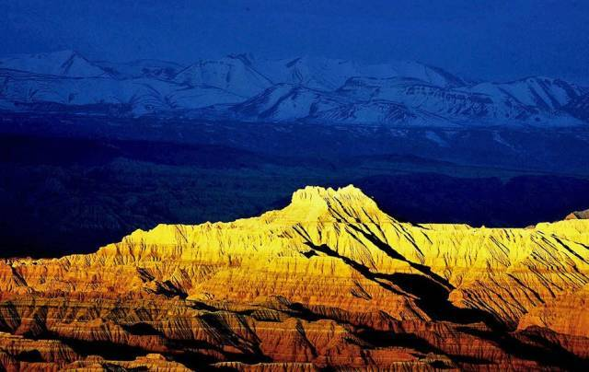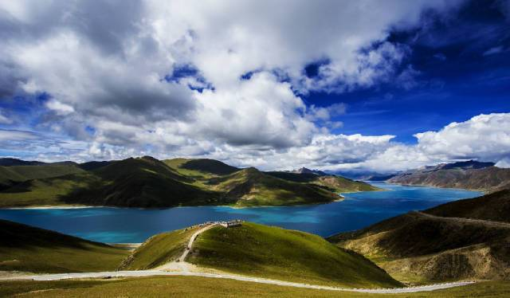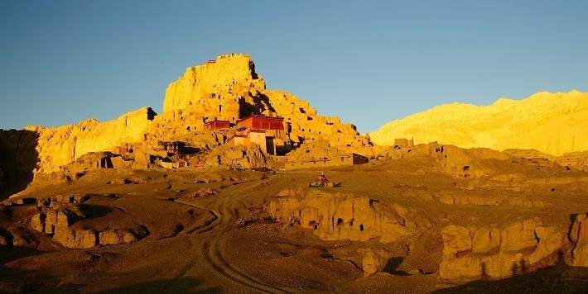

目的地介绍：
★深入世界屋脊——世界第三極，珠峰腳下朝聖，體會最難能可貴的經驗。
★珠穆朗玛峰（俗称珠峰）是喜马拉雅山脉的主峰，同时是世界海拔最高的山峰，海拨8848米。
★阿裡聖湖之旅：羊卓雍措、瑪旁雍措、拉昂措。
★轉山，圍繞世界中心－岡仁波齊，藏傳佛教的須彌山，仰望終年積雪的絕美山形。轉岡仁波齊峰，這是藏族同胞一生的夢想。
★高原湖泊無數，知名或不知名，有別於聖湖的名氣，更有寄身於曠野的大氣靈動。一生興許就一次機會目睹，絕對值。
★拜訪古象雄地區的古格王朝，窺探其曾經昌盛繁華的輝煌歷史。
★紮達土林的造型萬千，是歷經數千數萬年風霜雨雪的雕刻，壯闊淒美，氣勢奔放。
★無人區是野生動物的樂園，藏野驢、藏羚羊、黃羊、岩羊等等，隨時都有機會闖進你我視野。

——心靈與視覺的饗宴——

【線路優勢】此線路集西藏的雪山、冰川、海子、河灣、草原、峽谷、土林、野生動物等自然風光與人文景觀，皆是景區精華景點，既能欣賞壯麗山川景色，又能體驗濃郁的民族風情。特别是阿里和岡仁波齊的转山，更难能可贵。一路走，一路遊，一路攝影。
【特別贈送】礦泉水無限量供應、紅景天、鋼瓶氧氣罐。
【行程購物】絕不安排旅遊購物商店。

Top of the world, Tibet [Lhasa・Everest・Ali・Shannan] Grand Circle Line 20 Days (Walk around the Mountain Edition)
[Qinghai-Tibet Railway・Lhasa・Potala Palace・Yamdrok Lake・Shigatse・New Everest Base Camp・Rongbuk Monastery・Lake Manasarovar・Mount Kailash Zhuanshan・Guge Kingdom・Taqin・Shannan]
Deep experience ● Absolute mystery Exclusive custom ● Exclusive lines Shock scenery ●Guaranteed photos
Destination description：
★Go to the roof of the world — the world's third pole, at the foot of the Everest pilgrimage, experience the most valuable experience.
★Qomolangma (commonly known as Mount Everest) is the main peak of the Himalayas and the highest mountain in the world at 8,848 meters above sea level.
★Ali holy lake tour: Sera Monastery, Lake Manasorovar, Lhanag-tso Lake.
★Zhuanshan (Walk around the Mountain), around the center of the world - Mount Kailash, Mount Meru of Tibetan Buddhism, looking up at the beautiful mountain shape covered with snow all year round. Walk around the Mount Kailash, this is the lifelong dream of the Tibetan people.
★The plateau lakes are numerous, known or unknown, different from the fame of the holy lake, but also have the spirit of the atmosphere in the wilderness. Maybe once in a lifetime, it's definitely worth it.
★Visit the ancient Xiangxiong region of the Guge Kingdom, to see its once flourishing and prosperous glorious history.
★The shapes of Zhada Earth Forest are myriad, it is carved after thousands of years of wind, frost, rain and snow, magnificent and poignant, the momentum of bold and unrestrained.
★No Man's Land is the paradise of wild animals, Tibetan wild donkeys, Tibetan antelope, yellow sheep, rock sheep and so on, there are opportunities to break into our sight at any time.
——Spiritual and visual feast——

[Route advantage] This route is a collection of Tibetan snow mountains, glaciers, lakes, river bends, grasslands, valleys, earth forests, wildlife and other natural landscape and human landscape, all are the essence of scenic spots, not only to enjoy the magnificent scenery of mountains and rivers, but also to experience a strong national customs. Especially Ali and Kailash's zhuanshan(walk around the mountain) are more valuable. Walk all the way, tour all the way and take photos all the way.
[Special gift] Unlimited supply of mineral water, rhodiola healthy tea, oxygen supply equipment.
[Trip shopping] Never arrange tourist shopping store.

簡略行程：
D1：飞抵成都(四川省省會）→入住酒店 宿：成都
D2：成都市內自由活動一天→21:37火車赴拉薩 宿：火車上
D3：欣賞青藏鐵路沿途風光 宿：火車上
D4：拉薩站接團→抵達後自由活動→入住酒店休息 宿：拉薩
D5：拉薩（布達拉宮、大昭寺、八角街） 宿：拉薩
D6：拉薩→日喀則（羊卓雍錯、卡若拉冰川、白居寺、夏魯寺） 宿：日喀則
D7：日喀則→嘉措拉山口、加烏拉山口、新珠峰大本營—絨布寺 宿：絨布寺
D8：絨布寺→佩枯措、遠眺希夏邦馬峰→薩嘎 宿：薩嘎
D9：薩嘎（瑪旁雍措、拉昂措、岡仁波齊峰）→塔欽 宿：塔欽
D10: 塔欽→止熱寺 全天徒步轉山 宿：止熱寺
D11：止熱寺→仲哲普寺 全天徒步轉山 宿：仲哲普寺
D12：仲哲普寺→塔欽→紮達（上午徒步轉山、下午前往紮達土林遊覽） 宿：紮達
D13：紮達（古格王朝遺址、托林寺） 宿：紮達
D14：紮達（吉烏寺、拉昂措）→塔欽 宿：塔欽
D15：塔欽→薩嘎 後藏沿途風光 宿：塔欽
D16：薩嘎→日喀則 宿：日喀則
D17：日喀則→山南 （紮什倫布寺） 宿：山南
D18：山南→拉薩 （桑耶寺、青朴修行地、哲蚌寺） 宿：拉薩
D19：拉薩貢嘎機場成都（黃龍溪古鎮） 宿：成都
D20：彭鎮觀音閣・百年老茶館→乘機返程結束愉快之旅

Brief itinerary:
Day 1: Arrived in Chengdu (capital of Sichuan province) → Hotel
Accommodation: Chengdu
Day 2: Free activities in Chengdu city for one day → Take the train to Lhasa at 21:37
Accommodation: on the train
Day 3: Enjoy the scenery along the Qinghai-Tibet Railway
Accommodation: on the train
Day 4: Pick up the group at Lhasa station → Free activities upon arrival → Check in hotel and have a rest
Accommodation: Lhasa
Day 5: Lhasa (Potala Palace、Jokhang Temple、Barkhor Street)
Accommodation: Lhasa
Day 6: Lhasa → Shigatse (Yamdrok Lake、Karola Glacier、Palcho Monastery、Shalu Monastery)
Accommodation: Shigatse
Day 7: Shigatse → Jiacuola Mountain Pass、Jiawula Mountain Pass、New EBC — Rongbuk Monastery
Accommodation: Rongbuk Monastery
Day 8: Rongbuk Monastery → Peiku Lake、Far view of Shishapangma → Saga
Accommodation: Saga
Day 9: Saga (Lake Manasarovar、Lhanag-tso Lake、Mount Kailash) → Taqin
Accommodation: Taqin
Day 10: Taqin → Zhire Temple All day walking around the mountain
Accommodation: Zhire Temple
Day 11: Zhire Temple → Zhongzhepu Temple All day walking around the mountain
Accommodation: Zhongzhepu Temple
Day 12: Zhongzhepu Temple → Taqin → Zhada (Hike around the mountain in the morning and visit Zhada Earth Forest in the afternoon)
Accommodation: Zhada
Day 13: Zhada (Guge Kingdom、Tholing Monastery)
Accommodation: Zhada
Day 14: Zhada (Jiwu temple、Lhanag-tso Lake) → Taqin
Accommodation: Taqin
Day 15: Taqin → Saga Scenery along the Shigatse Area
Accommodation: Taqin
Day 16: Saga → Shigatse
Accommodation: Shigatse
Day 17: Shigatse → Shannan (Tashilhunpo Monastery)
Accommodation: Shannan
Day 18: Shannan → Lhasa (Samye Monastery、Qingpu Ashram、Drepung Monastery)
Accommodation: Lhasa
Day 19: Lhasa Gongga Airport to Chengdu (Huanglongxi Ancient Town)
Accommodation: Chengdu
Day 20: Peng Town Guanyin pavilion・Century-old tea house ~ Take the flight home and end the pleasant journey

詳細行程/Detailed itinerary:
D1：飞抵成都(四川省省會）→入住酒店
成都機場接團，乘車前往酒店入住休息。
公里數及行車時間：（10KM）。行車約26分鐘。 宿地海拔：成都500米
用餐：午餐（***）、晚餐（***） 住宿：成都賽侖吉地大酒店或同級（准五）
Day 1:Arrived in Chengdu (capital of Sichuan province) → Hotel
Pick up at Chengdu International Airport, check in hotel and have a rest.
Kilometres and driving time: 10KM. Driving about 26 minutes. Residential elevation: Chengdu 500M
Dining: Lunch (***) Dinner (***)
Accommodation: Chengdu Serengeti Hotel or equivalent

D2：成都市內自由活動一天→21:37火車赴拉薩
成都市內活動一天，晚21:37乘坐豪華空調列車前往拉薩。（注意：成都至拉萨的火车不是每天发班。）
行進順序：火車上
用餐：早餐（酒店內）、午餐（***）、晚餐：（火車上自理） 住宿：火車上
Day 2: Free activities in Chengdu city for one day → Take the train to Lhasa at 21:37
Free activity in the city of Chengdu for one day, take the luxury air-conditioned train to Lhasa at 21:37 PM. (note: the train from Chengdu to Lhasa does not run every day.)
Specific line: on the train
Dining: Breakfast (in the hotel) Lunch (***) Dinner (expenses will be self-covered on the train)
Accommodation: on the train

D3：欣賞青藏鐵路沿途風光
全天在列車上，经蘭州、西寧、格爾木，欣賞青藏鐵路沿途風光。（备注：火车内恒温、恒压，有供氧气措施）
行進順序：火車上
用餐：早餐（火車上自理）、午餐（火車上自理）、晚餐：（（火車上自理） 住宿：火車上
Day 3: Enjoy the scenery along the Qinghai-Tibet Railway
All day on the train, through Lanzhou, Xining, Golmud, enjoy the scenery along the Qinghai-Tibet Railway. (note: constant temperature and pressure in the train, with oxygen supply)
Specific line: on the train
Dining: Breakfast (expenses will be self-covered on the train) Lunch (self-covered) Dinner (self-covered)
Accommodation: on the train

D4：抵达拉薩火车站 →下午自由活動（适应高原环境）
上午抵達拉薩後，乘專車前往酒店，下午自由活動，讓身體適應高原的環境。
公里數及行車時間：（10KM）。行車約15分鐘。 宿地海拔：拉薩3650米
用餐：早餐（***）午餐（中式合菜50）、晚餐（中式合菜50） 住宿：福朋喜來登酒店或同級
Day 4: Pick up the group at Lhasa station → Free activities upon arrival → Check in hotel and have a rest (adapt to highland environment)
After arriving in Lhasa in the morning, take a tour bus to the hotel and have free activities in the afternoon to let our body adapt to the environment of the plateau.
Kilometres and driving time: 10KM. Driving about 15 minutes. Residential elevation: Lhasa 3650M
Dining: Breakfast (***) Lunch (Chinese dish 50) Dinner (Chinese dish 50)
Accommodation: Four Points by Sheraton Hotel or equivalent

D5：拉薩（布達拉宮、大昭寺、八角街）
【布達拉宮】始建於西元七世紀，是世界上海拔最高、最雄偉的宮殿。是拉薩乃至西藏最重要的象徵，被稱為“高原明珠”。
【大昭寺】鎮寺之寶是文成公主入藏時帶來的釋迦牟尼十二歲等身像，这是藏族老百姓心中為神聖靈驗的一尊佛像。
【八角街】位於拉薩市舊城區，是拉薩著名的轉經道和商業中心，較完整地保存了古城的傳統面貌和居住方式。
公里數及行車時間：（13KM）。行車約30分鐘。 宿地海拔：拉薩3650米
用餐：早餐（酒店）午餐（中式合菜50）、晚餐（中式合菜50） 住宿：福朋喜來登酒店或同級（准五）
Day 5: Lhasa (Potala Palace、Jokhang Temple、Barkhor Street)
[Potala Palace] Built in the 7th Century, it is the highest and most magnificent palace in the world. It is the most important
symbol of Lhasa and even Tibet, known as the "pearl of the plateau".
[Jokhang Temple] The treasure of the temple is the figure of a 12-year-old Sakyamuni brought by Princess Wencheng
when she entered Tibet, it is an efficaciously holy Buddha statue in the hearts of the Tibetan.
[Barkhor Street] Located in the old city of Lhasa, it is a famous circumanbulation and commercial center of Lhasa, which
has well preserved the traditional appearance and living style of the ancient city.
Kilometres and driving time: 13KM. Driving about 30 minutes. Residential elevation: Lhasa 3650M
Dining: Breakfast (in the hotel) Lunch (Chinese dish 50) Dinner (Chinese dish 50)
Accommodation: Four Points by Sheraton Hotel or equivalent

D6：拉薩→日喀則（羊卓雍錯、卡若拉冰川、白居寺、夏魯寺）
【羊卓雍措】海拔4441米，湖岸線長250公里，是西藏三大聖湖之一，被稱為“神女散落的綠松石耳墜”。
【卡若拉冰川】為年楚河東部源頭，整個冰川面積為9.4平方公里，是西藏三大大陸型冰川之一。
【白居寺】是一座藏傳佛教薩迦派、夏魯派、格魯派共存的寺院。
【夏魯寺】是西藏佛教後弘期初期所建古老寺院，是喇嘛教夏魯派（布頓派）的主寺。
公里數及行車時間：（371KM）。行車約7.5小時。 宿地海拔：日喀則3830米
用餐：早餐（酒店）午餐（中式合菜50）、晚餐（中式合菜50） 住宿：紮西曲塔大酒店或同級
Day 6: Lhasa → Shigatse (Yamdrok Lake、Karola Glacier、Palcho Monastery、Shalu Monastery)
[Yamdrok Lake] With an altitude of 4,441 meters and a coastline of 250 kilometers, it is one of the three holy lakes in
Tibet, known as the“turquoise ear-drop scattered by the Goddess”.
[Karola Glacier] For the eastern source of the Nianchu River, the entire glacier area of 9.4 square kilometers, is one of the
three major continental glaciers in Tibet.
[Palcho Monastery] It is a temple where Tibetan Buddhism Sakya, Shalu and Gelug sects of Tibetan Buddhism coexist.
[Shalu Monastery] It is an ancient temple built in the early stage of the post-Buddhism promotion period of Tibetan
Buddhism, it is the main temple of the Shalu sect(Budun sect) of Lamaism.
Kilometres and driving time: 371KM. Driving about 7.5 hours. Residential elevation: Shigatse 3830M
Dining: Breakfast (in the hotel) Lunch (Chinese dish 50) Dinner (Chinese dish 50)
Accommodation: Zhaxi Quta Style Hotel or equivalent

D7：日喀則→嘉措拉山口、加烏拉山口、新珠峰大本營—絨布寺：
【嘉措拉山口】也稱定日界，是珠峰國家級自然保護區的山口。天氣晴朗時，站在嘉措拉山口，不僅可以眺望到珠穆朗瑪峰，還可以眺望到另外三座海拔均在八千多米之上的卓奧友峰、洛子峰和馬卡魯峰。
【加烏拉山】海拔5200米，在这里可看到珠穆朗瑪峰卓立于萬山之巔的雄姿。
【珠峰大本營】是為了保護珠峰核心區而設立的一片保護地帶，海拔5200米。是觀賞拍攝珠峰的好位置之一。
【絨布寺】因為地勢高達海拔5100米以上，所以它被稱為世界上最高的寺院，離天堂最近的寺院。從這裡遙望珠穆朗瑪峰是一個非常不錯的視角，是最佳觀景台。
公里數及行車時間：（345KM）。行車約8小時。 宿地海拔：絨布寺4980米
用餐：早餐（酒店）午餐（中式合菜50）、晚餐（路餐） 住宿：絨布寺招待所或帳蓬營地
Day 7: Shigatse → Jiacuola Mountain Pass、Jiawula Mountain Pass、New EBC — Rongbuk Monastery
[Jiacuola Mountain Pass] Also known as Dingrijie, it is the mountain pass of the Mount Everest national nature reserve.
When the weather is clear, standing in the Jiacuola Mountain Pass, you can not only look out to Mount Everest, but also
can look out three other peaks, Cho Oyu, Lhotse and Makalu, all more than 8,000 meters above sea level.
[Jiawula Mountain Pass] With an altitude of 5,200 meters, here you can see the majestic appearance of Mount Everest standing on the top of thousands of mountains.
[New Everest Base Camp] It is a protective zone set up to protect the core area of Mount Everest, 5,200 meters above sea
level. One of the best places to see and photograph Everest.
[Rongbuk Monastery] It is known as the highest temple in the world because of its elevation of more than 5,100 meters
above sea level, the closest temple to the heaven. It is a great view of Mount Everest from here, the best viewing platform.
Kilometres and driving time: 345KM. Driving about 8 hours. Residential elevation: Rongbuk Monastery 4980M
Dining: Breakfast (in the hotel) Lunch (Chinese dish 50) Dinner (Chinese dish 50)
Accommodation: Rongbuk Monastery Hostels or Tent Camp

D8：絨布寺→佩祜措、遠眺希夏邦馬峰→薩嘎
【佩枯措】在湖边可一览全境在我国境内的8000米唯一的一座山峰——希夏邦玛峰。
【希夏邦玛峰】坐落在珠穆朗玛峰西北侧，为喜马拉雅山脉高峰之一，海拔8027米，为世界著名的第十四高峰。
公里數及行車時間：（345KM）。行車約8小時。 宿地海拔：薩嘎縣4480米
用餐：早餐（简餐）午餐（中式合菜50）、晚餐（中式合菜50） 住宿：西部驛站大酒店或同級
Day 8: Rongbuk Monastery → Peiku Lake、Far view of Shishapangma → Saga
[Peiku Lake] From the lake you can see the entire area in our country in the territory of the 8,000 meters of the only peak
—Shishapangma.
[Shishapangma] Located on the northwest side of Mount Everest, it is one of the highest peaks of the Himalayas, with an
altitude of 8,027 meters, it is the world famous 14th highest peak.
Kilometres and driving time: 345KM. Driving about 8 hours. Residential elevation: Saga County 4480M
Dining: Breakfast (simple meals) Lunch (Chinese dish 50) Dinner (Chinese dish 50)
Accommodation: West Station Hotel or equivalent

D9：薩嘎（瑪旁雍措、拉昂措、岡仁波齊峰）→塔欽
【瑪旁雍措】是藏地所稱三大“聖湖”之一，是亚洲四大河流的发源地，有“世界江河之母”的美譽。
【拉昂錯】人稱鬼湖，藏語意為“有毒的黑湖”，是鹹水湖。拉昂错是圣湖的近邻，这里的景色非常漂亮，湖边暗红色的小山，颜色迷离，卵石滩象一条白亮亮的银带，镶在湖边。
公里數及行車時間：（495KM）。行車約8小時。 宿地海拔：塔欽4560米
用餐：早餐（酒店内）午餐（中式合菜50）、晚餐（中式合菜50） 住宿：岡仁波齊酒店或同級

Day 9: Saga (Lake Manasarovar、Lhanag-tso Lake、Mount Kailash) → Taqin
[Lake Manasarovar] It is known as one of the three“holy lakes” in Tibet, is the birthplace of the four great rivers in Asia,
have a good reputation of“the mother of all rivers in the world”.
[Lhanag-tso Lake] Called ghost lake, in Tibetan language means the“toxic black lake”, is a saltwater lake. Lhanag-tso Lake
is a neighbor of the holy lake, the scenery here is very beautiful, there are dark red hills by the lake, color is blurred,
pebble beach like a white bright silver belt, set in the lake.
Kilometres and driving time: 495KM. Driving about 8 hours. Residential elevation: Taqin 4560M
Dining: Breakfast (in the hotel) Lunch (Chinese dish 50) Dinner (Chinese dish 50)
Accommodation: Kailash Hotel or equivalent

D10:塔欽→止熱寺 全天徒步轉山
【塔欽】转山线路以塔钦镇为起始点，塔钦面朝广阔的巴噶草原和柔情的玛旁雍错，也是转山朝拜者最大的补给站。
【止热寺】是转山途中最大的歇脚点，也是观看神山背面的最佳地点，因此我们将在这里住一晚上，第二天一早出发走后半段。
【岡仁波齊神山】是世界公認的神山，同時被中國西藏雍仲苯教、印度教、藏傳佛教、 以及古耆那教認定為世界的中心。
公里數及轉山時間：（塔欽到止熱寺24KM）。轉山時間約6-8小時。 宿地海拔：止熱寺5089米
用餐：早餐（簡餐）午餐（路餐）、晚餐（路餐） 住宿：招待所或帳蓬營地
Day 10: Taqin → Zhire Temple All day walking around the mountain
[Taqin] The pilgrimage journey starts at the town of Taqin, which faces the vast plains of Baga grassland and the gentle Lake Manasarovar, and is the largest supply station for pilgrims.
[Zhire Temple] It is the biggest stop on the way around the mountain and the best place to see the back of the holy mountain, so we will stay here for a night and leave the next morning for the second half route.
[Mount Kailash] It is recognized as a sacred mountain in the world, and it is also recognized as the center of the world by Bonismo, Hinduism,Tibetan Buddhism and ancient Jainism.
Kilometres and walking time: Taqin to Zhire Temple 24KM. Walking about 6-8 hours. Residential elevation: Zhire Temple 5089M
Dining: Breakfast (simple meals) Lunch (solid food) Dinner (solid food)
Accommodation: Hostels or Tent Camp

D11：止熱寺→仲哲普寺 全天徒步轉山
【卓玛拉山口】海拔5650米，山口布满了五颜六色的经幡。这里是转山路上海拔最高点，也是地球上海拔最高的垭口。【仲哲普寺】是在冈仁波齐神山转山途中必须经过的寺庙。
公里數及轉山時間：（止熱寺至仲哲普寺20KM）。轉山時間約6-8小時。 宿地海拔：仲哲普寺4810米
用餐：早餐（簡餐）午餐（路餐）、晚餐（路餐） 住宿：招待所或帳蓬營地
Day 11: Zhire Temple → Zhongzhepu Temple All day walking around the mountain
[Zhuomala Mountain Pass] With an altitude of 5,650 meters, the pass is dotted with colorful prayer flags. This is the highest point on the mountain road, it's also the highest pass(a narrow place between two mountains) on earth.
[Zhongzhepu Temple] It is a temple that must be passed on the way to Mount kailash.
Kilometres and walking time: Zhire Temple to Zhongzhepu Temple 20KM. Walking about 6-8 hours.
Residential elevation: Zhongzhepu Temple 4810M
Dining: Breakfast (simple meals) Lunch (solid food) Dinner (solid food)
Accommodation: Hostels or Tent Camp

D12：仲哲普寺→塔欽→紮達（上午徒步轉山、下午乘车前往紮達土林遊覽）
今日返回塔欽，为转山之旅画下一个完美的句号。
【紮達土林】是古格王国的宫殿和寺院的遗址。是世界上最典型、分佈面積最大的第三系地層風化形成的土林。
公里數及轉山、行車時間：（仲哲普寺至塔欽約12KM。步行用時約3小時.塔欽至紮達行車約230KM,行車約4小時。）
用餐：早餐（簡餐）午餐（路餐）、晚餐（中式合菜50） 宿地海拔：紮達縣3700米 住宿：土林城堡酒店或同級
Day 12: Zhongzhepu Temple → Taqin → Zhada (Hike around the mountain in the morning and visit Zhada Earth Forest in the afternoon)
Today we return to Taqin, draw a perfect full stop to our pilgrimage journey.
[Zhada Earth Forest] The ruins of palaces and temples of the Guge Kingdom. It is the most typical and distributed area of the earth forest formed by weathering of tertiary strata in the world.
Kilometres, walking time and driving time: Zhongzhepu Temple to Taqin 12KM, walking about 3 hours. Taqin to Zanda, driving about 4 hours.
Dining: Breakfast (simple meals) Lunch (solid food) Dinner (Chinese dish 50)
Residential elevation: Zanda County 3700M
Accommodation: Tulin Castle Hotel or equivalent

D13：紮達（古格王朝遺址、托林寺）
【古格王朝】始建于10世纪前后，为吐蕃王室后裔所建。为了躲避战乱，吐蕃王室偏居于此七百多年，传承了20多代国王。
【托林寺】始建于997年，由于古格王朝信奉佛教，托林寺便是王朝的第一个佛教寺院，也是王朝的御用寺院。这个寺庙中珍藏着寺庙创始人，古格王国第二代王子的肉身化石。
公里數及行車時間：（50KM）。行車時間約2.5小時 宿地海拔：紮達縣3700米
用餐：早餐（酒店）午餐（中式合菜50）、晚餐（中式合菜50） 住宿：土林城堡酒店或同級
Day 13: Zhada (Guge Kingdom Ruins、Tholing Monastery)
[Guge Kingdom] It was built around the 10th century for the descendants of the Tubo royal family. In order to escape the war, the Tubo royal family lived here for more than 700 years and inherited more than 20 generations of Kings.
[Tholing Monastery] Built in 997, because of Guge Kingdom believed in Buddhism, so Tholing Monastery was the first Buddhist temple of the Guge Kingdom, it was also the imperial temple of the dynasty. The temple treasured the fossilized body of its founder, the second prince of the Guge Kingdom.
Kilometres and driving time: 50KM. Asphalt road. Driving about 2.5 hours. Residential elevation: Zanda County 3700M
Dining: Breakfast (in the hotel) Lunch (Chinese dish 50) Dinner (Chinese dish 50)
Accommodation: Tulin Castle Hotel or equivalent

D14：紮達（吉烏寺、拉昂措）→塔欽
【吉烏寺】吉烏寺坐落在聖湖——西藏阿裏地區普蘭縣瑪旁雍措的西岸，寺區碧草青青，殿宇巍峨，靜靜的聖湖清澈見底，氣勢壯觀，風景幽雅迷人，從矗立的山頂居高臨下，俯瞰湖面，寺區盡收眼底。
【拉昂措】人稱鬼湖，藏語意為“有毒的黑湖”，是鹹水湖。拉昂错是圣湖的近邻，这里的景色非常漂亮，湖边暗红色的小山，颜色迷离，卵石滩象一条白亮亮的银带，镶在湖边。
公里數及行車時間：（230KM）。行車時間約4小時 宿地海拔：塔欽4560米
用餐：早餐（酒店）午餐（中式合菜50）、晚餐（中式合菜50） 住宿：岡仁波齊酒店或同級
Day 14: Zhada (Jiwu temple、Lhanag-tso Lake) → Taqin
[Jiwu temple] Jiwu temple is located on the holy lake—on the west bank of Lake Manasorovar in Burang County, Ali region of Tibet, the temple area with green grass, lofty buildings, quiet holy lake clear to see the bottom, imposing manner is magnificent, elegant and charming scenery, from the top of the hill, overlooking the lake, to have a panoramic view of temple area.
[Lhanag-tso Lake] Called ghost lake, in Tibetan language means the“toxic black lake”, is a saltwater lake. Lhanag-tso Lake
is a neighbor of the holy lake, the scenery here is very beautiful, there are dark red hills by the lake, color is blurred,
pebble beach like a white bright silver belt, set in the lake.
Kilometres and driving time: 230KM. Driving about 4 hours. Residential elevation: Taqin 4560M
Dining: Breakfast (in the hotel) Lunch (Chinese dish 50) Dinner (Chinese dish 50)
Accommodation: Kailash Hotel or equivalent

D15：塔欽→薩嘎 後藏沿途風光
【後藏沿途風光】后藏人烟稀少，茫茫草地形成了一个动物乐园，途经雅鲁藏布江源头马泉河，在烟云飘渺的雪山脚下，雪山、湖泊都铺在一块一望无际犹如翠绿绒毡的草地上。
公里數及行車時間：（495KM）。行車時間約8小時 宿地海拔：薩嘎縣4480米
用餐：早餐（酒店）午餐（中式合菜50）、晚餐（中式合菜50） 住宿：西部驛站大酒店或同級
Day 15: Taqin → Saga Scenery along the Shigatse Area
[Scenery along the Shigatse Area] Shigatse Area is a sparsely populated area where the vast grasslands form an animal paradise, through the Brahmaputra River source Maquan River, at the foot of the misty snow mountains, the snow-capped mountains and lakes lay on a green velvet lawn that stretched as far as the eye could see.
Kilometres and driving time: 495KM. Driving about 8 hours. Residential elevation: Saga County 4480M
Dining: Breakfast (in the hotel) Lunch (Chinese dish 50) Dinner (Chinese dish 50)
Accommodation: West Station Hotel or equivalent

D16：薩嘎→日喀則
今日乘車途徑“萬川之源”的昂仁縣、拉孜返回日喀則。 一路上基本都是高山、草原和河流。
公里數及行車時間：（448KM）。行車時間約8小時 宿地海拔：日喀則3830米
用餐：早餐（酒店）午餐（中式合菜50）、晚餐（中式合菜50） 住宿：紮西曲塔大酒店或同級
Day 16: Saga → Shigatse
Today by tour bus through "the source of rivers" of Ngamring County, Lhatse back to Shigatse. There are high mountains, grasslands and rivers along the way.
Kilometres and driving time: 448KM. Driving about 8 hours. Residential elevation: Shigatse 3830M
Dining: Breakfast (in the hotel) Lunch (Chinese dish 50) Dinner (Chinese dish 50)
Accommodation: Zhaxi Quta Style Hotel or equivalent

D17：日喀則（紮什倫布寺） →山南
【紮什倫布寺】位於日喀則市城西的尼瑪山東面山坡上，為四世之後歷代班禪駐錫之地，它與拉薩的“三大寺”甘丹寺、沙拉寺、哲蚌寺合稱藏傳佛教格魯派的“四大寺”，寺內供奉有世界最大鍍金佛像——強巴佛。
公里數及行車時間：（322KM）。行車時間約5.5小時 宿地海拔：山南3700米
用餐：早餐（酒店）午餐（中式合菜50）、晚餐（中式合菜50） 住宿：山南賓館或同級
Day 17: Shigatse(Tashilhunpo Monastery) → Shannan
[Tashilhunpo Monastery] Located on the eastern hillside of mount Nima in the west of Shigatse, it is the place where successive Panchen lived after the fourth Panchen, together with the “three major monasteries of Lhasa”, Ganden Monastery, Sera Monastery and Drepung Monastery, it is known as the “four major monasteries” of the Gelug sect of Tibetan Buddhism, the temple is consecrate the world's largest gilded Buddha—Strong Buddha.
Kilometres and driving time: 322KM. Driving about 5.5 hours. Residential elevation: Shannan 3700M
Dining: Breakfast (in the hotel) Lunch (Chinese dish 50) Dinner (Chinese dish 50)
Accommodation: Chengdu Serengeti Hotel or equivalent

D18：山南→拉薩 （桑耶寺、青朴修行地、哲蚌寺）
【桑耶寺】是藏傳佛教史上第一座佛、法、僧三寶俱全的寺廟，素有“西藏第一座寺廟”美稱。
【青朴修行地】又被称为藏传佛教的“终南山”，据说，在青朴修行，念一遍六字真言，胜过别处念百遍，在青朴修行一天，功德胜过在别处修行一年。
【哲蚌寺】位於拉薩西郊更丕烏孜山下，與甘丹寺、沙拉寺合稱拉薩三大寺。哲蚌，藏語意為"米聚"，象征繁榮，它是格魯派中地位最高的寺院。
公里數及行車時間：（166KM）。行車時間約3.5小時 宿地海拔：拉薩3650米
用餐：早餐（酒店）、午餐（中式合菜50）、晚餐（中式合菜50） 住宿：福朋喜來登酒店或同級
Day 18: Shannan → Lhasa (Samye Monastery、Qingpu Ashram、Drepung Monastery)
[Samye Monastery] It is the first Buddhist temple in the history of Tibetan Buddhism with Buddha, Dhama and Sangha, known as the "first temple in Tibet" laudatory name.
[Qingpu Ashram] Also known as the "Zhongnan Mountain" of Tibetan Buddhism, it is said that practicing in Qingpu, read the Om Mani Padme Hum once, better than to read it a hundred times elsewhere, practice one day in Qingpu, merit is better than practice in other places for a year.
[Drepung Monastery] Located in the western suburbs of Lhasa under the Gengpiwuzi Mountain, together with Ganden Monastery and Sera Monastery collectively known as the three major temples in Lhasa. Drepung, which means "rice gathering" in Tibetan, symbolizes prosperity, it is the highest status temple of the Gelug sect.
Kilometres and driving time: 166KM. Driving about 3.5 hours. Residential elevation: Lhasa 3650M
Dining: Breakfast (in the hotel) Lunch (Chinese dish 50) Dinner (Chinese dish 50)
Accommodation: Four Points by Sheraton Hotel or equivalent

D19：拉薩貢嘎機場成都（黃龍溪古鎮 ）
前往拉薩貢嘎機場，乘機返回成都。
【黃龍溪古鎮】素有“影視城”、“中國好萊塢”之稱，這裡的古街、古樹、古廟、古建築使人產生穿越時空錯覺。
公里數及行車時間：（105KM）。行車時間約2.5小時 宿地海拔：成都500米
用餐：早餐（酒店）、午餐（中式合菜50）、晚餐（中式合菜50） 住宿：成都賽侖吉地大酒店或同級
Day 19: Lhasa Gongga Airport to Chengdu (Huanglongxi Ancient Town)
To Lhasa Gonggar Airpor, take the plane back to Chengdu.
[Huanglongxi Ancient Town], which is known as "movie city" and "Hollywood of China", the ancient streets, trees, temples and ancient buildings here create the illusion of time travel. After that, go to the Shuangliu International Airport and end the pleasant journey.
Kilometres and driving time: 105KM. Driving about 2.5 hours. Residential elevation: Chengdu city 500M
Dining: Breakfast (in the hotel) Lunch (Chinese dish 50) Dinner (Chinese dish 50)
Accommodation: Chengdu Serengeti Hotel or equivalent

D20：彭鎮觀音閣・百年老茶館→乘機返程結束愉快之旅
【彭鎮觀音閣老茶館】是一座擁有百年歷史的老茶館，是遠近聞名的攝影聖地，吸引了無數國內外遊客前往。之後前往雙流國際機場，乘機返程結束愉快之旅！
公里數及行車時間：（26KM）。城區路。行車約50分鐘。
用餐：早餐（酒店內） 午餐***
Day 20: Peng Town Guanyin pavilion・Century-old tea house ~ Take the flight home and end the pleasant journey
[Peng Town Old Teahouse] This is a century-old teahouse, it attracts numerous domestic and foreign tourists. After that, go to the Shuangliu International Airport and end the pleasant journey！
Kilometers and driving time: 26KM. Urban Road, driving about 50 minutes.
Dining: Breakfast (in the hotel) lunch: ***

頌：旅途愉快！收穫滿滿！
——Have a nice trip! Full of harvest!——

